15 January 2016

Call for applications for young people to take part in the
Congress of Local and Regional Authorities’ 30th and 31st sessions

22 – 24 March and 18 - 20 October 2016, Strasbourg (France)

In close co-operation with the European Youth Foundation and the Council of Europe Youth Department, the Congress of Local and Regional Authorities of the Council of Europe is inviting a number of young people to take an active part in its 30th and 31st sessions.

Background

“Conscious that direct involvement of youth in the affairs of society remains essential, as a safeguard for democracy and for sustainable development in the municipalities and regions”, and in view of the apparent disengagement of young people from conventional political participation in recent years, the Congress of Local and Regional Authorities of the Council of Europe has been taking a closer look at the issue of youth participation. Its work over the past three years has concluded that, contrary to popular belief, young people are still committed to participating in society, however they are engaging differently in a society in which they feel marginalised from the political process.

Since October 2014, the Congress has been inviting young people from different backgrounds – youth activists, youth workers, students, young politicians – to take part in its sessions, to have their say in the debates and to exchange with Congress members on the issues on the agenda.

What is the Congress and what does taking part in its sessions involve?
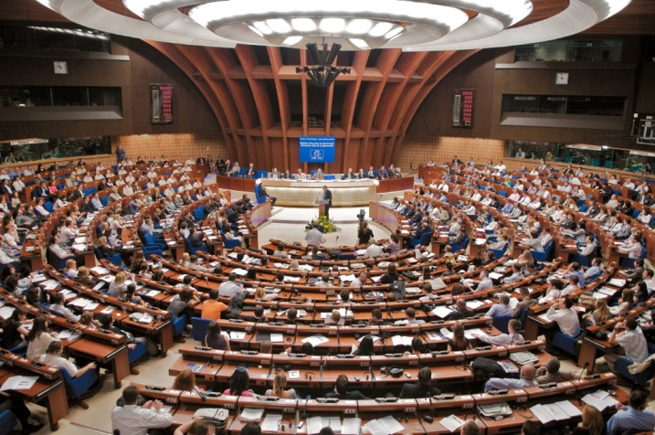
The Congress is a pan-European political assembly, its 648 members hold elective office (they may be regional or municipal councillors, mayors or presidents of regional authorities) and represent over 200,000 authorities in 47 European States. Its role is to promote local and regional democracy, improve local and regional governance and strengthen authorities' self-government. It meets in session twice a year.

Like other political assemblies, such as national parliaments or local/regional councils, the sessions are formal gatherings where the Congress members examine reports, hold thematic debates and adopt recommendations.

The youth delegates, one from each member State, will sit in the hemicycle, alongside the Congress members for the whole of the session. An obligatory one-day preparatory session, run according to non-formal education principles and a welcome evening will be organised prior to the sessions. Youth delegates must commit to taking part in the whole of the two 2016 sessions: from 20 March and 17 October (19.00) to the debriefing sessions on 24 March and 21 October (17.00). An optional intercultural farewell evening will be organised on 24 March and 21 October.

Aims and objectives

By inviting a number of young people to take an active part in its 30th and 31st sessions the Congress, in co-operation with the Council of Europe Youth Department, aims to create a space for dialogue between the selected youth delegates and local and regional elected representatives and to enable young people to express their views on the issues being debated.

The specific objectives are to:

- allow a number of young people, from different walks of life, to take an active part in the 30th and 31st sessions and in the meetings of the Congress’ three committees;
- raise the youth delegates’ awareness of the Council of Europe’s and Congress’ aims and work, in particular their policies on youth and participation, notably the co-management system;
- examine with the youth delegates the state of young people’s participation at local and regional levels in European society and identify opportunities and obstacles to its effective implementation;
- give the youth delegates space to prepare a contribution to a number of Congress debates on thematic issues to ensure an exchange of views between them and Congress members;
- motivate the youth delegates to multiply the information and experience acquired during the sessions on their return home;
- through formal and informal exchanges, promote dialogue and co-operation between the elected representatives and the youth delegates in a spirit of mutual understanding and respect and encourage the exchange of good practices as well as the promotion of existing models of youth-led structures;
- illustrate to the Congress the importance of officially including young elected representatives in member States’ national delegations, both as full and substitute members.

Partners

The participation of young people in these sessions has been made possible thanks to the close co-operation between the Congress of Local and Regional Authorities and the Youth Department of the Council of Europe. Their participation and the programme are financed by the Congress with a contribution from the European Youth Foundation. The Advisory Council on Youth plays an important role in advising and guiding the youth delegates throughout the week, as does the European Youth Forum.

Programme

The youth delegates must arrive by 19.00 at the latest on Sunday 20 March and Monday 17 October. They will be invited to take part in the debates organised during the plenary sittings and the sessions of the Chamber of Local Authorities and the Chamber of Regions. In addition, they will participate in the meetings of the three Congress committees: the Monitoring Committee, the Governance Committee and the Current Affairs Committee. Youth delegates are allowed to take the floor in sittings and meetings according to the Congress’ rules and procedures however they are not allowed to vote.

A workshop, led by professional youth trainers from the Council of Europe’s pool of trainers, will be organised for the youth delegates on the eve of the sessions. The youth delegates will have opportunities for informal exchanges with Congress members in the margins of the session sittings and during the side events. An obligatory debriefing and evaluation meeting will be held on the last afternoon of each session (end 17.00). An optional intercultural evening will be organised that same evening.

The youth delegates’ participation in the whole of the programme is obligatory, from 19.00 on the day preceding the session to the final day of the session at 17.00. In addition, they must undertake preparatory work before the sessions to facilitate the learning process. If youth delegates wish to take part in the intercultural farewell evenings, the Council of Europe will cover the cost of accommodation for the final evening.

Profile of participants

The youth delegates, one per national delegation, should meet the following criteria:

- be open, committed and motivated to develop and strengthen dialogue between young people and elected representatives at local/regional level;
- be between 16 and 30 years old;
- have been resident in one of the Council of Europe member States for a minimum of five years;
- be a member of a local/regional youth council or parliament, or local/regional council or assembly or executive, or a representative of a youth NGO, or a youth-led structure, or involved in youth work, or a local or regional elected representative;
- be available and motivated to engage in the whole of the activity;
- have an interest in actively participating in policy making at local and/or regional levels;
- be able to multiply the information obtained during the session on their return home;
- speak English fluently (NB: during the sittings they may also speak in one of the official or working languages for which interpretation is provided (English, French, German, Italian, Russian, Turkish)).

Application procedure and selection of participants

Those wishing to apply to take part in the 30th and 31st Congress sessions must do so by means of the application form enclosed. Participation in only one session is not possible.

Applicants must also submit a short video, for example via YouTube, of no more than 30 seconds, to support their application. The link to the video should be sent together with the application.

The deadline for submitting completed applications is Friday 5 February 2016.

Completed application forms must be sent to: congress.youth@coe.int.

The youth delegates will be selected by the Congress’ ad hoc group on youth participation which is composed of members of the Congress and of the Joint Council on Youth. The panel will ensure the selected applicants represent a balanced group with regard to gender, cultural background, experience, etc.

Applicants will be informed of the results of the selection procedure by 22 February 2016.

NB: by accepting an invitation to the sessions and confirming the travel tickets offered by the Congress Secretariat, the youth delegates commit themselves to being present according to the modalities described herein. Any youth delegate cancelling their participation must reimburse the Council of Europe the costs incurred unless a valid reason is provided, for example illness certified by a doctor’s note.

Travel, subsistence and accommodation

The youth delegates’ travel and subsistence expenses will be covered jointly by the Congress of Local and Regional Authorities and the European Youth Foundation according to the Council of Europe’s rules.

Accommodation will be provided and paid for by the organisers, in single-occupancy or shared rooms according to availability. The organisers cannot cover the cost of accommodation elsewhere.

For further information, please contact:

Joanne HUNTING
Project Manager on Youth Issues
Congress of Local and Regional Authorities
E-mail: congress.youth@coe.int

Application form

To take part in the Congress’ 30th and 31st sessions

22-24 March and 18-20 October 2016, Strasbourg (France)

Personal details

First name
Last name
Date and place of birth
Gender (M/F/other)
Nationality
Have you been living in your current country of residence for more than five years?
Home address

Address where you will be residing at the time of the sessions

If you are selected, the Council of Europe will cover your cost of travel from this address and return, no other.
E-mail
Facebook address
Telephone number
Mobile number
Working language
Activity/profession
Name of organisation/authority/structure

Experience and motivation (in no more than 200 words for each reply: longer answers will be disregarded)

What is your personal motivation to take part in the Congress’s 30th and 31st sessions?
What experience do you have of representing young people in relations with local and regional authorities, for example in NGOs, youth associations, youth councils, etc?
What do you expect to be able to contribute to the session?
What do you expect to learn from this experience?
How will you disseminate the information obtained during the session on your return home?

Your views on youth participation and dialogue (in no more than 200 words for each reply: longer answers will be disregarded)

Why are youth participation and dialogue at local and regional levels important to you and young people in general?
Please describe briefly your experience of making your voice heard by local and regional authorities or by society at large; the local/regional that structures exist in your area?
What challenges have you faced or do you face in making your voice heard by elected representatives and how do/have you overcome them?
Which innovative, diverse and fresh ideas/projects do you or your organisation use to make your voices heard?
Is there any additional information you feel may be relevant to your application?
Link to your video

Practical questions

Do you have any special needs or requirements, for example dietary, medical, allergies, disability, etc?
If you are invited to take part in the sessions, will you require assistance in obtaining a visa for France?

Please return completed application forms to congress.youth@coe.int, by Friday, 5 February 2016 at the latest.

Congress Recommendation 128 (2003) on the revised European Charter on the Participation of Young People in Local and Regional Life.
In line with the provisions of the Convention on the Participation of Foreigners in Public Life at Local Level (CETS No.144).
During the non-formal sessions organised alongside the official debates and committee meetings, the working language will be English.
Facebook will be used by the group to prepare the session and to exchange information.

