EFFECT4buildings

Projekta “Efektīvi finanšu instrumenti ēku energoefektivitātes paaugstināšanas pasākumu ieviešanai” (EFFECT4buildings)
Starptautiskā ieinteresēto pušu sanāksme un energoefektīvu objektu apskate
27.-29. 08.2019. Vīlande, Pērnava un Tartu, Igaunijā

(!) Pasākums norisināsies angļu valodā
(!) Aicinām līdz 15. augustam pieteikt savu dalību, reģistrējoties saitē: https://forms.gle/tdAjS4ZvTVTvbzsSA

Programma
Laiks | Notikums
27. augusts
14:10 | Izbraucam no Cēsīm, Smilšu laukums, Uzvaras bulvāris 22, Cēsis
14:40 | Pieturvieta Valmieras Kultūras centra stāvlaukumā, Rīgas iela 10, Valmiera
16:30 | Ierašanās viesnīcā un iekārtošanās numuriņos Viljandi Grand Hotel www.ghv.ee
17:00 – 18:30 | Apskates objekts Vīlandē: Privātmāja, kas būvēta atbilstoši pasīvās ēkas principiem
18:30 | Apskates objekts: Vīlandes bērnudārza pieredze, ieviešot Energoefektivitātes pakalpojuma līgumu (EPC)
Brīvais laiks
28. augusts
7:30 – 8:20 | Brokastis viesnīcā
8:20 – 10:00 | Ceļā uz Pērnavu
10:00 – 11:00 | Apskates objekts: Saules paneļu parks Pērnavā  http://www.baltic-course.com/eng/good_for_business/?doc=150299
11:00 – 12:30 | Atpakaļ ceļš uz Vīlandi
13:00 | Pusdienas Vīlandē
14:00 – 15:00 | Ceļā uz Tartu
15:00 | Apskates objekts: Tartu centralizētā dzesēšanas stacija “Fortum”
16:00 | Apskates objekts: ESCO principa ieviešana Aura ūdens atrakciju parkā
17:00 – 18:30 | “EFFECT4buildings” darba grupa Igaunijas Nacionālajā muzejā – iedvesmojoši stāsti par projekta aktivitāšu labajiem piemēriem un veidiem, kā uzrunāt un iesaistīt ēku apsaimniekotājus https://erm.ee/en
18:30 | Igaunijas Nacionālā muzeja apskate
19:00 | Vakariņas Nacionālā muzeja telpās
20:00 – 21:00 | Ceļā no Tartu līdz viesnīcai Vīlandē
29. augusts
7:30 – 8:20 | Brokastis viesnīcā un izrakstīšanās no numuriņiem
8:30 – 11:00 | Mājupceļš uz Valmieru un Cēsīm

Informācija par apskates objektiem (angļu valodā)
Private passive house which built by one of the Technopol partners. More information ( http://sense.ee/ )  Detached house in Viljandi is a three-storey prefabricated wooden building with a heated floor area of 240 m2. Energy efficiency has been the core idea while planning and positioning the building in this location, which is reflected in the room layout and architectural solution. Building has thick cellulose insulation layer, thermally optimized large windows, ventilation with heat recovery and solar-thermal and PV-system. Energy Performance Certificate (EPC) based on energy calculations is class A which meets energy efficiency requirements of nearly zero energy buildings (nzeb). The house also complies with International Passive House requirements and was awarded as the “Most energy efficient prefabricated building of the year 2016”, awarded by the Estonian Woodhouse Association. | 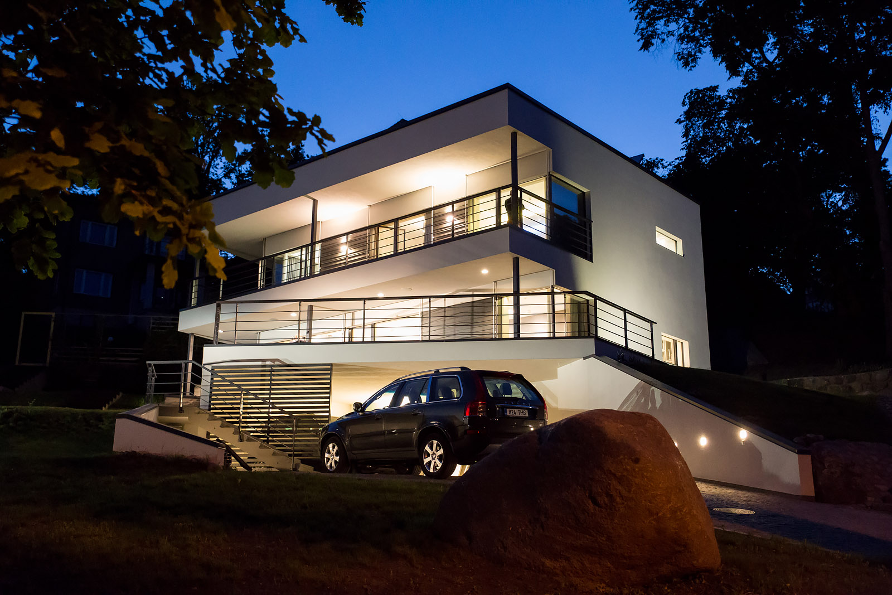
Viljandi kindergarden EPC  It is typical EPC/MSC project. It is rather old building. Owner of the building is local municipality (City of Viljandi). The main drivers are IAQ-problems (lack of ventilation, problems with lightening system, high energy demand for space heating etc.) and surely lack of money! Estonian first ESCO company AU Energiateenus did it very well – they built new ventilation and space heating system, change windows and insulate the envelope elements. To achieve energy goals they even add the PV-system. Now municipality and ESCO-company are monitoring the energy consumption. Definatly it is very good example how to do. | 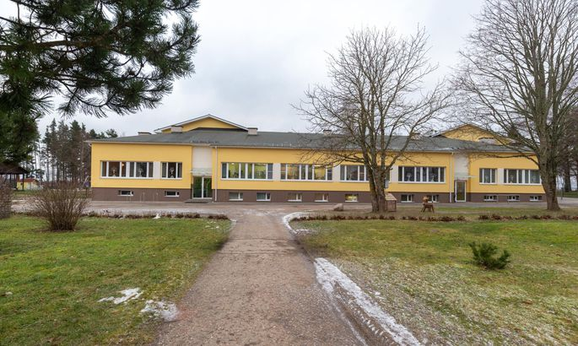
Tartu - Fortum distance cooling  It is the first district cooling network in Estonia. While the river water is cold enough, they are using it directly (passive cooling) and while the river water is warmer, they use it to cool the condensers. | 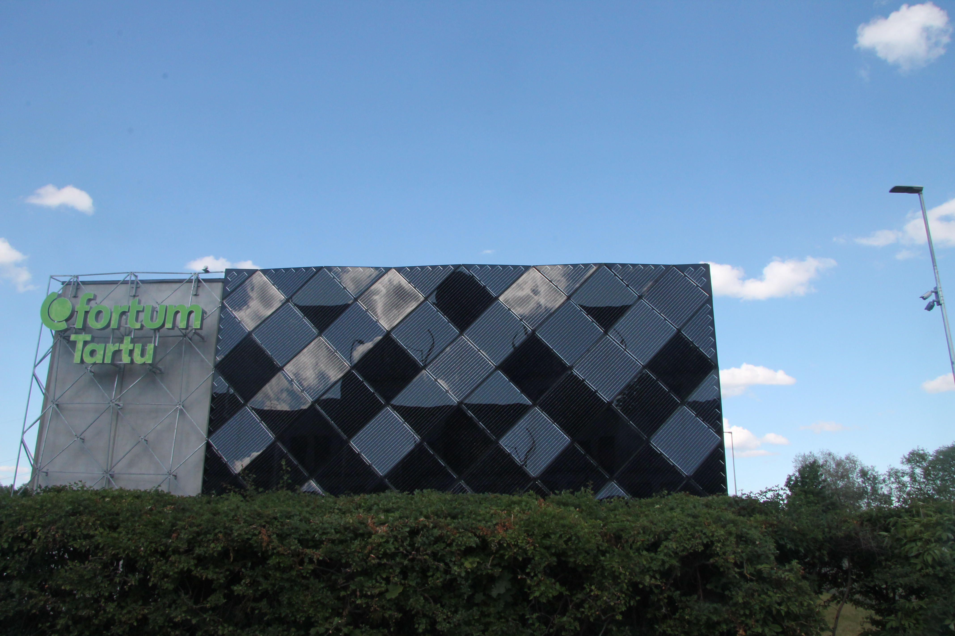
Aura water park renovation (https://aurakeskus.ee/)
It is typical EPC project like Viljandi kindergarden.
Estonian National Museum  New building (RKAS development). In architectural side it is surely worth of visiting. We could have quick tour and after that we could visit technical rooms as well. | 