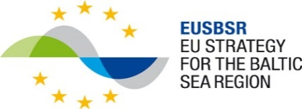

PA Education
Workshop
increasing employability through lifelong learning and using resources of longer lives

25 April 2016, 09:00 – 12.00
Association of Local Governments
Mazā Pils iela 1, Rīga

08:30 Registration / coffee

09:00 Welcome and introduction

09:10 Participants introduce themselves and if applicable projects/initiatives – “elevator
pitch” focusing on effects

09:30 EUSBSR, PA Education, Flagship concept, Action 4 – a society of longer lives
Solveg Schmidt, Policy Area Coordinator
Anders Bergström, Policy Area Coordinator

10:00 Challenges of life-long learning to get the full use of resources of longer lives in each of participating regions/countries
Working in groups / coffee break included

11:00 Building a flagship – discussions on common challenges and possible solutions as well as main stakeholders of the topic addressed

11:45 Closing remarks

12:00 End

